Math Competition Review

Approximations:
1. (UM 1997) Which number is the largest?
1⁴⁴, 2³³, 3²², 4¹¹; 1,000,000,000
See also 99#17,00#8, 01#2,03#16, 06#22

Algebra:
Setting up equations. Substitution, elimination
The times between 7 and 8 o’clock, correct to the nearest minute, when the hands of a clock will form an angle of 84 degrees are:
(A) 7:23 and 7:53 (B) 7:20 and 7:50 (C) 7:22 and 7:53 (D) 7:23 and 7:52 (E) 7:21 and 7:49
Rates: Distance (work)= rate x time
A train, a hour after starting, meets with an accident which detains it a half hour, after which it proceeds at ¾ its former rate and arrives 3½ hours late. Had the accident happened 90 miles farther along the line, it would have arrived only 3 hours late. The length of the trip in miles was:
(A) 400 (B) 465 (C) 600 (D) 640 (E) 550
Solve for z: x²+y²+z²=317, x+y+z=25, xy=10
See also UM 98#22, 99#15, 01#15, 02#22, 03#18, 04#22, 05#20,24

Logarithms:
Know: laws of logarithms
(AHSME 1954-38) If log 2 = .3010 and log 3 = .4771, the value of x when 3^{x+3} = 135 is approximately
(A) 5 (B) 1.47 (C) 1.67 (D) 1.78 (E) 1.63
(NYSML 1986) Suppose 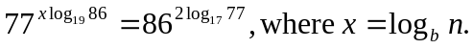 Compute the ordered pair of positive integers (b,n) that satisfy these conditions, where b is as small as possible but greater than 16.
See also UM 97#4, 05#19

Polynomials:
Viete’s theorem: 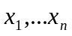 roots of polynomial 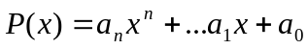. Let s_{k}= sum of the products of the x_{i} taken k at a time. Then 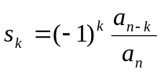.
Symmetric Polynomials
Common difference of differences in quadratic
(AHSME 1952-47) If r and s are the roots of the equation ax²+bx+c=0, the value of 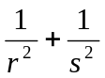 is:
(A) b²-4ac (B) 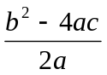 (C) 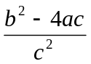 (D) 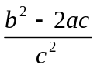 (E) None of these
See also UM 97#20, 24, 99#19, 24, 01#23, 04#16.

Number Theory:
Modular arithmetic, divisibility, playing with digits, Diophantine (integer) equations
Find the last digit of 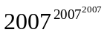. Find the remainder upon division by 9.
(AIME) Let n=2³¹3¹⁹. How many positive integer divisors of n² are less than n but do not divide n?
2²⁹ is a nine-digit number all of whose digits are distinct. Which digit is missing?
(AHSME 1997-29) Call a positive real number special if it has a decimal representation that consists entirely of digits 0 and 7. For example, 700/99 = 7.070707 . . . and
77.007 are special numbers. What is the smallest n such that 1 can be written as a sum of n special numbers?
(A) 7 (B) 8 (C) 9 (D) 10
(E) 1 cannot be represented as a sum of finitely many special numbers
(BCC 1995) If x and y are positive integers the number of solutions of 2x+y=335 is ___
See also UM 00#12,25,01#21,22,03#17,04#21,25

Geometry, Triangles:
Extended Law of Sines 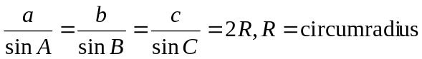
Law of Cosines a²=b²+c²-2bc cosA, Pythagorean Theorem a²+b²=(>,<) c² (acute, obtuse)
Area
Angle bisectors, perpendicular bisectors, medians, altitudes
Median formula 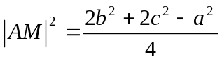
(AHSME 1953-50) One of the sides of a triangle is divided into segments of 6 and 8 units by the point of tangency of the inscribed circle. If the radius of the circle is 4, then
the length of the shortest side is
(A) 12 units (B) 13 units (C) 14 units (D) 15 units (E) 16 units
(ARML 2007) Equilateral triangles are erected on the sides of rectangle ABCE, facing outwards. If the sum of the areas of ABCE and triangles AEF and DEC exceeds the area of BDF by 33, compute the area of rectangle ABCE.
See also UM 99#23, 04#24, 06#23, 98#25, 99#25, 05#18

Circles:
Power-of-a-point, using the Pythagorean theorem, angles.
(AHSME 1955-44) In circle O chord AB is extended to C so that BC equals the radius. CO is drawn and when extended, intersects the circle at D. AO is drawn. What is the relationship between 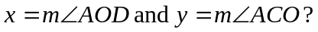
See 06#21

Look for a pattern:
1972-35 Equilateral triangle ABP with side AB of length 2 inches is placed inside a square AXY Z with side of length 4 inches so that B is on side AX. The triangle is rotated clockwise about B, then P, and so on along the sides of the square until P,A, and B all return to their original positions. The length of the path in inches traversed by vertex P is equal to
(A) 4π (B) 32π/3 (C) 12π (D) 40π/3 (E) 15π
1995-30 A large cube is formed by stacking twenty-seven congruent small cubes. The
large cube is sliced by a plane that is perpendicular to one of its internal
diagonals. The plane meets n of the small cubes, but does not contain any of
their vertices. A possible value for n is (A) 13 (B) 14 (C) 17 (D) 19 (E) 20

Invariance Principle
When there is repetition look for what does not change!
(UM 2003) 25. A playing field is filled with 2001 Trolls, 2002 Griffins, and 2003 Dragons. Whenever two animals of different species shake hands, they both instantly disappear and are replaced by an animal of the third species. This game continues for some time, until there is only one species of animal left in the field. Which of the following is a possible end position of such a game?
a. Exactly 5 Trolls remain. b. Exactly 25 Griffins remain. c. Exactly 9 Trolls remain. d. Exactly 4 Dragons remain. e. Exactly 6 Dragons remain.
See also 05#16

Box Principle
If kn+1 objects are distributed among n boxes, one of the boxes will contain at least k+1 objects.
What is the least number of numbers such that I can be sure that there will exist 2 a,b such that 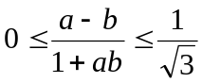? (Hint: reinterpret)
See also UM02#25,03#22,05#21

Counting, Probability, Combanitorics
(AMY 2006) A 15x15 square is tiled with unit squares. Each vertex is colored either red or blue. There are 133 red points. Two of these red points are corners of the original square, and another 32 red points are on the sides. The sides of the unit squares are colored according to the following rule: If both endpoints are red, then it is colored red, if both points are blue it is colored blue; if one is red and one is blue, then it is colored yellow. Suppose there are 196 yellow sides. How many blue segments are there?
(UM 1997) 9. Seven black unit squares and 2 red ones on a table are to be assembled into a 3×3 square, by matching sides. How many different designs can be made? Two designs are different when they look different no matter how you rotate them on the table. Flipping is forbidden. 7,10, 12, 14, 17
1983-26 The probability that event A occurs is 3/4; the probability that event B occurs is 2/3. Let p be the probability that both A and B occur. The smallest interval necessarily containing p is the interval (A) [1/12, ½] (B) [5/12, ½] (C) [1/2, 2/3] (D) [5/12, 2/3] (E) [1/12, 2/3]
PIE/Sieve Formula: Add, subtract overlaps of 2, add overlaps of 3, …
See also UM 99#14, 24, 01#10, 02#25, 03#24, 05#22, 05#23, 05#25

Trigonometry
Know all identities! including product-to-sum, sum-to-product.
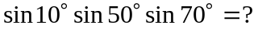
(AMC 2002) Let a and b be real numbers such that 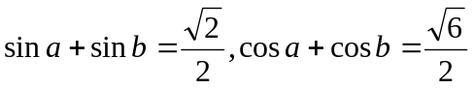. Find sin(a+b). A) B)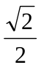 C) D)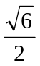 E)1
Simplify 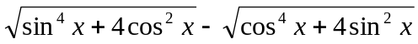
See also UM97#18,01#11,06#25

Sums
Arithmetic, geometric, telescoping series
Find 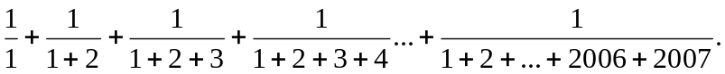 See also 06#24.

Logic See UM97#14,00#23,01#6
Functional Equations
1979-26 The function f satisfies the functional equation f(x) + f(y) = f(x + y) − xy − 1 for every pair x, y of real numbers. If f(1) = 1, then the number of integers n 6= 1 for which f(n) = n is
(A) 0 (B) 1 (C) 2 (D) 3 (E) infinite
See UM 99#20,00#24,06#15

Inequalities
Squares are always greater than or equal to 0.
Harmonic-geometric-arithmetic-quadratic mean inequality
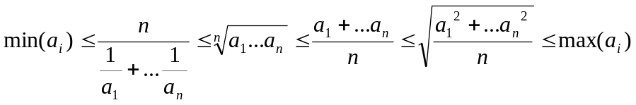

Websites
http://www.math.umd.edu/highschool/mathcomp/pastexams.shtml
http://www.unl.edu/amc/e-exams/e6-amc12/archive12.shtml
OUR website!
http://www.artofproblemsolving.com/Forum/weblog.php?w=916

